

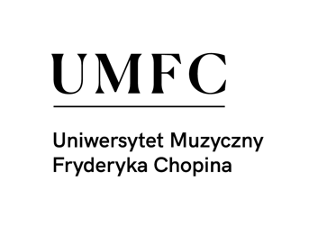

**INTERNATIONAL ACCORDION SEMINAR**

**LUSŁAWICE 2024**

**ENTRY FORM**

**LUSŁAWICE (POLAND), 14.07 — 21.07. 2024**

**Name:**

**First name:**

**Date of birth:**

**Address:**

**Mobile phone:**

|  |
| --- |
| **Payment by bank transfer: 2400 PLN**  **NEST BANK nr 16 2530 0008 2090 1072 0896 0001** |

|  |
| --- |
| **STOWARZYSZENIE AKORDEONISTÓW POLSKICH**  **Ul. Kurhan 18/02, 02-203 Warszawa** |